# Themes across Control and Reinforcement Learning

We invite registrations for a workshop on Themes across Control and Reinforcement Learning: <https://www.cwi.nl/en/events/cwi-research-semester-programmes/workshop-themes-across-control-and-reinforcement-learning/>

**Please recommend this also to your students, post-docs and other colleagues!**

Control theory and reinforcement learning converge on a shared objective: facilitating autonomous, real-time decision-making to optimize dynamical processes. Historically, these disciplines have diverged in assumptions regarding available prior information and in analytical techniques applied. However, recent advances bridging the two domains are fostering collaborations. As part of a [research semester on Control Theory and Reinforcement Learning at CWI, Amsterdam, NL](https://www.cwi.nl/en/events/cwi-research-semester-programmes/control-theory-and-reinforcement/), we have a workshop on broad themes across these topics.

Dates: **24-25 March 2025**

Venue: **CWI** (Research Institute for Mathematics and Computer Science), Amsterdam,

We have a line-up of renowned speakers:

[Ann Nowé, Vrije Universiteit Brussel, Belgium](https://ai.vub.ac.be/team/ann-nowe/)

[Bert Kappen, Radboud Univ, Nijmegen, Netherlands](https://www.snn.ru.nl/~bertk/)

[Davide Grossi, Univ of Amsterdam, University of Groningen, Netherlands](https://davidegrossi.me/)

[Frans Oliehoek, TU Delft, Netherlands](https://www.fransoliehoek.net/wp/)

[Harri Lähdesmäki, Aalto University, Finland](https://www.aalto.fi/en/people/harri-lahdesmaki)

[Jens Kober, TU Delft, Netherlands](http://www.jenskober.de/aboutme.php)

[Sean Meyn, Univ. of Florida, USA](https://meyn.ece.ufl.edu/about/)

[Sofie Haesaert, Eindhoven University of Technology, Netherlands](https://www.tue.nl/en/research/researchers/sofie-haesaert)

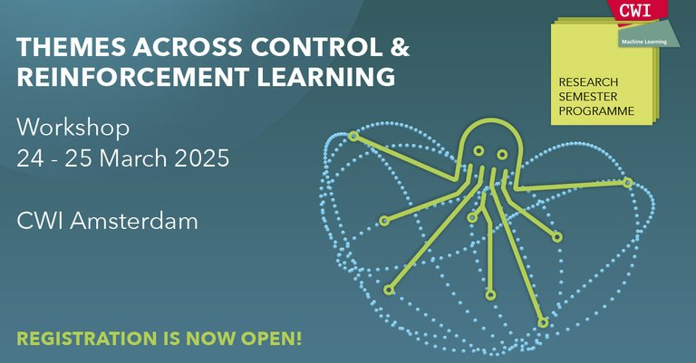

*Part of the*[*research semester programme*](https://www.cwi.nl/en/events/cwi-research-semester-programmes/control-theory-and-reinforcement/)*, which includes a*[*spring school (17-21 March)*](https://www.cwi.nl/en/events/cwi-research-semester-programmes/spring-school-control-theory-and-reinforcement-learning/)*.*

*Download and*[*advertise the poster*](https://www.cwi.nl/documents/199888/poster_A3_Control_Theory_and_Reinforcement_Learning.pdf)*!*